**Домашнее задание №5**

**по “Базам даннных”**

**Морина Ильи Олеговича**

**Группы БПИ №215**

**Задание №1.**

**Наполнение базы данных library_bd:**

INSERT INTO "Reader" (id, last_name, first_name, address, birth_date)  
VALUES (1, 'Smith', 'John', '123 Main St', '1990-01-01'),  
 (2, 'Johnson', 'Sarah', '456 Elm St', '1985-05-10'),  
 (3, 'Garcia', 'Maria', '789 Maple Ave', '1995-11-20'),  
 (4, 'Kim', 'David', '321 Oak Blvd', '1982-03-15'),  
 (5, 'Lee', 'Jenny', '654 Pine St', '1998-07-25');  
  
INSERT INTO "Book" (isbn, title, author, pages_num, year, pub_id)  
VALUES (1234567, 'To Kill a Mockingbird', 'Harper Lee', 281, 1960, 1),  
 (2345678, '1984', 'George Orwell', 328, 1949, 2),  
 (3456789, 'Pride and Prejudice', 'Jane Austen', 279, 1813, 3),  
 (4567890, 'The Great Gatsby', 'F. Scott Fitzgerald', 180, 1925, 1),  
 (5678901, 'The Catcher in the Rye', 'J.D. Salinger', 224, 1951, 4);  
  
INSERT INTO "Publisher" (id, pub_name, pub_address)  
VALUES (1, 'HarperCollins Publishers', '195 Broadway, New York, NY'),  
 (2, 'Secker & Warburg', '14 Carlisle St, London'),  
 (3, 'T. Egerton, Military Library', 'Whitehall, London'),  
 (4, 'Little, Brown and Company', '1290 Avenue of the Americas, New York, NY'),  
 (5, 'Penguin Random House', '1745 Broadway, New York, NY');  
  
INSERT INTO "Category" (id, name)  
VALUES (1, 'Fiction'),  
 (2, 'Non-fiction'),  
 (3, 'Mystery'),  
 (4, 'Romance'),  
 (5, 'Science fiction');  
  
INSERT INTO "Copy" (id, copy_number, book_isbn, shelf_position)  
VALUES (1, 1, 1234567, 1),  
 (2, 2, 1234567, 2),  
 (3, 1, 2345678, 3),  
 (4, 1, 3456789, 4),  
 (5, 1, 5678901, 5);  
  
INSERT INTO "Borrowing" (id, reader_nr, book_copy, return_date)  
VALUES (1, 1, 1, '2022-01-01'),  
 (2, 2, 3, '2022-02-01'),  
 (3, 3, 5, '2022-03-01'),  
 (4, 4, 4, '2022-04-01'),  
 (5, 5, 2, '2022-05-01');  
  
INSERT INTO "BookCategory" (id, category_id, book_isbn)  
VALUES (1, 1, 1234567),  
 (2, 1, 2345678),  
 (3, 4, 3456789),  
 (4, 3, 5678901),  
 (5, 5, 5678901);

**После просмотра задания наполнение базы данных пришлось немного изменить дабы запросы давали хоть какой-то вывод.**

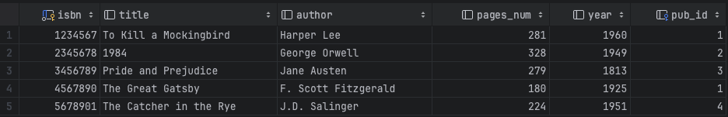

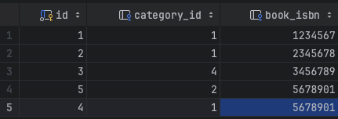

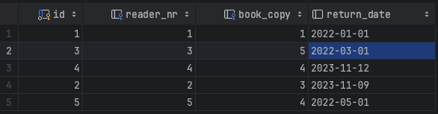

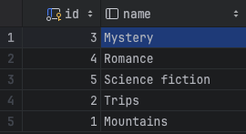

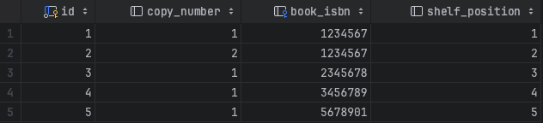

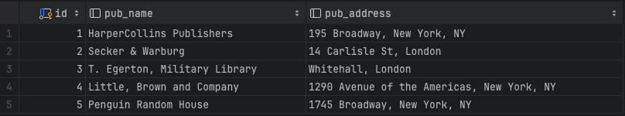

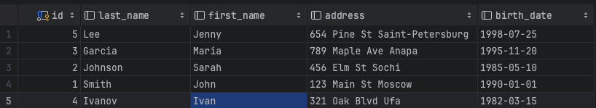

**Запросы к library_bd:**

/* Задание 1 (а) */  
SELECT "last_name" FROM "Reader" WHERE "address" LIKE '%Moscow%';  
  
/* Задание 1 (б) */  
SELECT author, title  
FROM "Book"  
JOIN "Copy" ON "Book".isbn = book_isbn  
JOIN "Borrowing" ON "Copy".id = book_copy  
JOIN "Reader" ON "Borrowing".reader_nr = "Reader".id  
WHERE "Reader".first_name = 'Ivan' AND "Reader".last_name = 'Ivanov';  
  
/* Задание 1 (в) */  
SELECT bc.book_isbn  
FROM "BookCategory" bc  
JOIN "Category" c1 ON bc.category_id = c1.id  
WHERE c1.name = 'Mountains'  
AND bc.book_isbn NOT IN (  
 SELECT bc2.book_isbn  
 FROM "BookCategory" bc2  
 JOIN "Category" c2 ON bc2.category_id = c2.id  
 WHERE c2.name = 'Trips'  
);  
  
/* Задание 1 (г) */  
SELECT r.last_name, r.first_name  
FROM "Reader" r  
JOIN "Borrowing" b ON r.id = b.reader_nr  
WHERE b.return_date IS NOT NULL AND b.return_date < *current_date*;  
  
/* Задание 1 (д) */  
SELECT last_name, first_name FROM "Reader" r  
 JOIN "Borrowing" br on r.id = br.reader_nr  
 JOIN "Copy" cp on br.book_copy = cp.id  
 WHERE cp.book_isbn  
 IN (SELECT book_isbn FROM "Copy" cop1  
 JOIN "Borrowing" br1  
 on cop1.id = br1.book_copy  
 JOIN "Reader" r1  
 on br1.reader_nr = r1.id  
 WHERE r1.first_name = 'Ivan' AND r1.last_name = 'Ivanov')  
 AND (r.first_name not like 'Ivan' OR r.last_name not like 'Ivanov');

**Выводы после запросов**

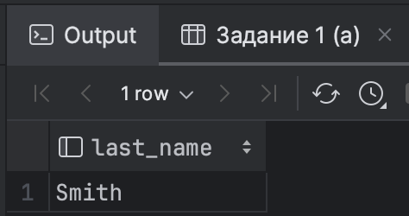



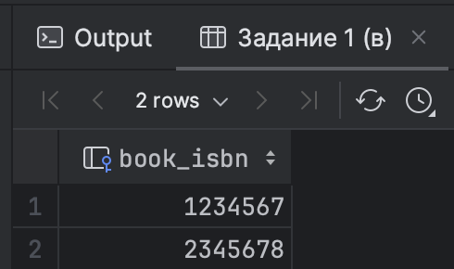

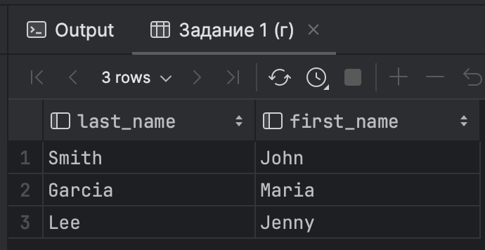

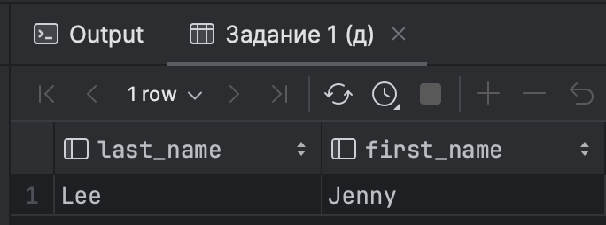

**Задание №2.**

**Наполнение базы данных station_db.**

INSERT INTO "City" ("id", "region", "name") VALUES  
(1, '77', 'Moscow'),  
(2, '78', 'Saint Petersburg'),  
(3, '69', 'Tver'),  
(4, '23', 'Sochi'),  
(5, '23', 'Anapa');  
  
INSERT INTO "Station" ("name", "city_id", "tracks") VALUES  
('Moscow st.', 1, 3),  
('Saint Petersburg st.', 2, 2),  
('Tver st.', 3, 4),  
('Sochi st.', 4, 1),  
('Anapa st.', 5, 2);  
  
INSERT INTO "Train" ("train_nr", "length", "start_station_name", "end_station_name") VALUES  
(101, 10, 'Moscow st.', 'Saint Petersburg st.'),  
(102, 8, 'Sochi st.', 'Anapa st.'),  
(103, 12, 'Moscow st.', 'Tver st.'),  
(104, 6, 'Moscow st.', 'Sochi st.'),  
(105, 14, 'Saint Petersburg st.', 'Anapa st.');  
  
INSERT INTO "Connection" ("id", "from_station", "to_station", "train_nr", "departure", "arrival") VALUES  
(1, 'Moscow st.', 'Tver st.', 101, '2021-01-01 08:00:00', '2021-01-01 09:00:00'),  
(2, 'Tver st.', 'Saint Petersburg st.', 101, '2021-01-01 09:00:00', '2021-01-01 10:00:00'),  
(3, 'Moscow st.', 'Saint Petersburg st.', 101, '2021-01-01 08:00:00', '2021-01-01 10:00:00'),  
(4, 'Sochi st.', 'Anapa st.', 102, '2021-01-01 09:00:00', '2021-01-01 10:30:00'),  
(5, 'Moscow st.', 'Tver st.', 103, '2021-01-01 10:30:00', '2021-01-01 12:00:00'),  
(6, 'Moscow st.', 'Sochi st.', 104, '2021-01-01 11:30:00', '2021-01-01 12:30:00'),  
(7, 'Saint Petersburg st.', 'Anapa st.', 105, '2021-01-01 12:00:00', '2021-01-01 14:00:00');

**После просмотра задания наполнение базы данных пришлось немного изменить дабы запросы давали хоть какой-то вывод.**

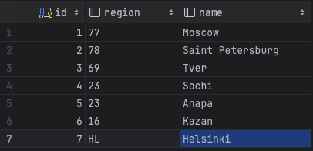

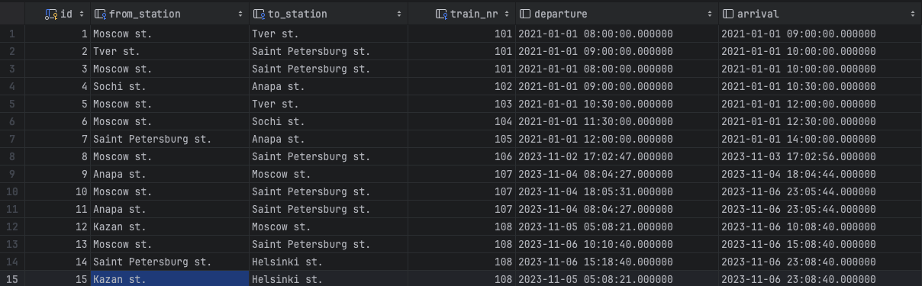

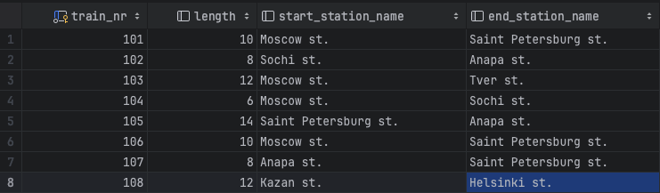

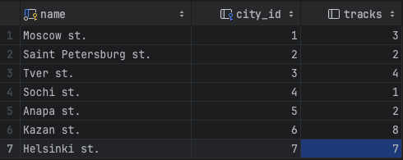

**Запросы к базе данных station_db:**

/* Задание 2 (а) */  
SELECT c.id  
FROM "Connection" c  
JOIN "Train" t ON c.train_nr = t.train_nr  
JOIN "Station" s1 ON t.start_station_name = s1.name  
JOIN "Station" s2 ON t.end_station_name = s2.name  
WHERE s1.name = 'Moscow st.' AND s2.name = 'Tver st.';  
  
/* Задание 2 (б) */  
SELECT c.id  
FROM "Connection" c  
JOIN "Train" t ON c.train_nr = t.train_nr  
JOIN "Station" s1 ON c.from_station = s1.name  
JOIN "Station" s2 ON c.to_station = s2.name  
WHERE s1.name = 'Moscow st.' AND s2.name = 'Saint Petersburg st.' AND *DATE*(c.departure) = *DATE*(c.arrival);

**Выводы после запросов:**

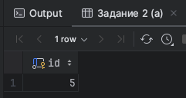

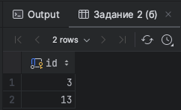

**Что в итоге получилось в проекте:**

**(см. следующий лист)**

